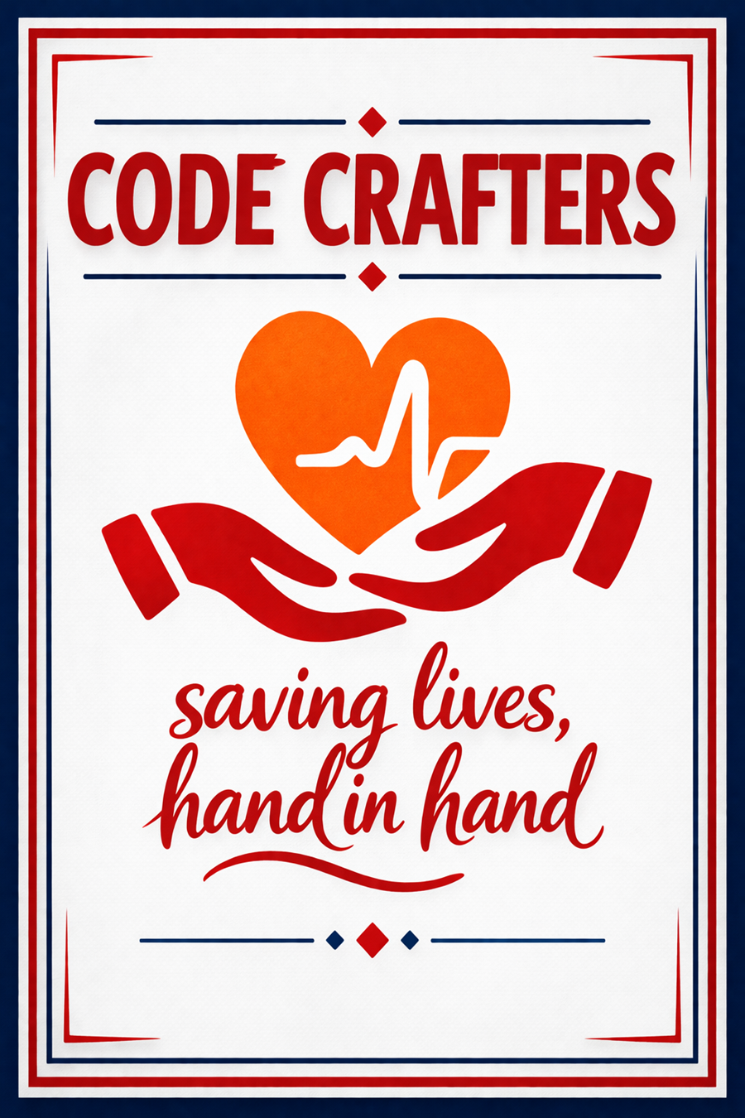
Table of Contents
What is Hand-In-Hand? 3
What is Organ Donation? 3
Why Do People Need Organ Donations? 3
Target audience: Who will use our website 4
Features of website 4
Technologies Used 5
Usefulness of this website 5
CHALLENGES/LIMITATIONS 6
PRIVACY CONCERNS (PERSONAL DATA) 6
LIMITATIONS/INTERNET ACCESS 6
MISUNDERSTANDING ABOUT ORGAN DONATIONS 6
Summary of the Report 7
The Importance of Hand-in-Hand 7
Role in Saving Lives 7

There are a lot of people around the world who need organ transplants to stay alive. Many people who could be organ donors do not know how to sign up or are not sure if they want to. The systems we have now for organ donation are not very good. They are hard to use. Do not always tell people what is going on. This means that people who need transplants might not get them on time. Our website, Hand-in-Hand, wants to make things better. It will help people who want to donate organs, people who need transplants and doctors talk to each other and work together. Hand in Hand will make it easier and safer for people to donate organs. This will help more people get the transplants they need and Hand in Hand will help save lives. Hand-in-Hand is really important because it will help people who need organ transplants and people who want to be organ donors.

What is Hand-In-Hand?
Hand-In-Hand is a platform designed to help patients who need organ transplants connect with potential donors in a safe, transparent and accessible way. The aim of this platform is to reduce long waiting lists for organ transplants and improve access to life-saving medical care.
The platform also helps reduce corruption that sometimes occurs in organ donation systems such as illegal organ trading and unfair prioritization of wealthy patients. Hand-In-Hand promotes transparency and ensures ethical organ allocation based on medical need.

What is Organ Donation?
Organ donation occurs when a person donates one or more organs to help another person survive or improve their quality of life. Donating organs is a selfless act that saves lives and gives patients a second chance.

Why Do People Need Organ Donations?
Organ donation becomes necessary when organs stop functioning properly due to diseases or severe medical conditions.
- Kidney failure may require a kidney transplant.
- Liver diseases such as cirrhosis may require a liver transplant.
- Severe heart conditions may require a heart transplant.
- Serious lung diseases may require a lung transplant.

Target audience: Who will use our website
A person who is willing to help, save or improve the life of someone in need of a transplant by donating a kidney, parts of their liver, tissue and part of their placenta which all are examples of a living organ donation. Any person who is in good health and is clear of defined chronic diseases that might adversely affect the recipient will be considered as a possible donor. As well as those who have died in a hospital care unit or emergency department and have agreed to become donors after their departure. This website educates various institutions including high schools and primary schools, tertiary institutions, companies and any institution or gathering requesting a talk. During the visits, our team opens awareness programs in those public spaces so the website and its effectiveness can spread, so by using education, many are encouraged to donate for those in need. Patients who require transplant are well prioritized because they are the main reason for the whole website, so this website helps them speed up the process of finding matches without wasting any second of their life. Our website provides patients with information about the process of the waiting list, so they can stay informed about any updates on their donation requests. Transplant Stories Archives - Tell families of donors will find great assistance in this website simply because it will keep them updated about the process and steps to follow to successfully donate, support is offered too and they will also see how much impact their donation has made in someone else’s life. They will also be educated further based on the differences in categories of donations that can be made by healthcare professionals. This website helps healthcare professionals to quickly detect if there is a match for any current patient in need of donation, as this website also provides types of blood groups that patients have, the healthcare professional’s job is made easier since they can now confirm themselves that the patient has indeed found a match.

Features of website
Online Donor Registration, a fast, one-minute online form to register as an organ and tissue. Donor database secure, maintained database used to track donor registration statistics, including demographic information, and to store contact dry of potential donors. Educational resources, comprehensives information on how organ donation works, the difference between tissue and organ donation, and answers to common questions Information. Request/Brochures, ability to request information, including donor cards and brochures, which can be used to inform families. Emergency Contact Info, a dedicated emergency hotline (e.g.,0800 22 66 11) for notifying the foundation about a potential donor after hours. Donation/ Contribution Options: Opportunities to make financial donations (once-off or monthly) to support the foundations’ work
News& Awareness Updates: Sections dedicated to upcoming events (e.g., national walks), media campaigns, social media links Online Registration system, a quick, one- minute digital form to register as an organ and tissue donor. Information on the registration process, details on how to register online, by phone, or through app- based tools, including steps to obtain donor cards and ID sticker. Educational resources, information on the difference between organ and tissue donation, including which organs (heart, lungs, liver, kidneys, pancreas) and tissue (bone, skin, corneas, heart valves) can be donated. Information for next of kin, Guidance for family members on what to do in the event of a loved one’s death, including contact information for the transplant network. How to become a living donor, information on donating a kidney or a portion of the liver whilst still alive. Contact information, emergency contact numbers for after-hours enquiries, as well as office contact details for the organization. Statistics and impact, data demonstrating the impact of donation (e.g., that one donor save up to 7 or 8 lives).

Technologies Used
The "Hand-in-Hand" website is built with technology. These technologies are HTML, CSS, and database. HTML is used to organize the content on the website. This includes things like information about organ transplantation and donor profiles. The website is made easy to navigate using HTML. The HTML structure helps the site be accessible to everyone and shows up in search results. We also designed the website with CSS. This means designing the layout and styling the HTML structure. The website should look professional on all devices. So, we use things like grids and nice typography. The website is about organ transplantation. We try to make it look compassionate and friendly.

Usefulness of this website
This website for organ donations gives straightforward access to people who want to register as LifeSavers. Therefore, it helps to reduce the national transplant waiting list securing that patients receive the life-saving transplant they need and allowing recipients to return to normal productive lives. These platforms allow healthcare experts to instantly locate eligible donors and coordinate life-saving matches with patients in need. Also, this website often includes educational resources that help people understand the donation of organ process, address common myths and concerns, and provide information on the impact of donation. This can help people make informed decisions about their own donation choices. Lastly but not least for registration and education, this website often offers tools and resources to help people discuss their donation wishes with loved ones. This is a critical step, as family consent is often required for donation to proceed. By providing resources and support, at the same time this website can help increase the number of registered donors and ultimately save more lives. The websites also maintain secure databases of registered donors, which medical professionals can access to identify potential matches for transplant recipients. This helps to ensure that organs are matched with recipients quickly and efficiently and at the same time they maximize the chances of successful transplants. Therefore, by creating this website, it improves the knowledge in people by:
- Keeping donor information safe and matching donors with the recipients
- Sharing information to help people understand about organ donation.
- Establishing trust in the transplant system
- Allowing people to share their donation decision with their family

CHALLENGES/LIMITATIONS

PRIVACY CONCERNS (PERSONAL DATA)
Maintaining confidentiality of delicate medical information or donor’s identity is a very important thing that we do. Using this website for organ search will not mean that your crucial information will be revealed, it will remain private. We assure you that your data will be kept private as possible.

LIMITATIONS/INTERNET ACCESS
Not having internet access won’t limit you from donating because we are able to come to schools, clinics, hospitals etc., we have come to educate you about this website and organ donations. We also have posters that will explain furthermore about donations like who, how, why, and when to donate. It is important to donate as it shows that we work hand in hand and save lives as people living in South Africa.

MISUNDERSTANDING ABOUT ORGAN DONATIONS
Donors tend to fear that there may be some mistakes during operation and then doctors fail to save them leading them to death. They also fear that they may get some illness (side effects) after donation that cannot be prevented, but we assure you that there will be no possible mistakes or you will be in warm hands. Some people say that organ donation is against their religious beliefs. It is important to understand the advantages and disadvantages of donating before donating to prevent confusion or misunderstanding.

Summary of the Report
Hand-in-Hand faces a strong shortage of registered donors, with over thousands of adults and children waiting for transplants in South Africa alone. The Hand-in-Hand maintains a digital register for public registration, aiming to educate the public and increase donor registration through educational talks, social media, and digital platforms. It emphasizes community focused approach with online registration and is needed a huge demand for transplants. The way to boost donation rates is by getting the word out on social media, making education interactive, and just talking about it more. We believe focusing on social media campaigns, interactive education, and making conversations about donation more mainstream could really move the needle.

The Importance of Hand-in-Hand
Hand-in-Hand is not just a website; it is an important lifeline. Its importance lies in Accessible Education: It explains the process of organ donations, educating the public on how one person can save many lives. Consensual registrations: It provides a digital space where users can register in under a minute, promoting easy access to the national database. Getting families on board: If donors share their wishes with loved ones, it makes it way easier for the family to make a decision when the time comes.

Role in Saving Lives
The Hand-in-Hand website is a proactive, life-saving tool that operates 24/7 to register new Donors by simplifying the process, Hand-in-Hand increases the number of potential donors directly reducing the long waiting lists. It helps transplant teams quickly identify donors, and gives families hope by letting them celebrate their loved ones’ legacy.
To make Hand-in-Hand even better, here's what could help:
- Add AI chatbots to answer questions instantly
- Partner with hospitals to quickly identify donors when it matters
- Share real stories from donors and recipients to connect with people
- Encourage users to share their donor status on social media
- Add an "Emergency" button for reporting potential donors outside office hours

